Specifications
marine AIS, AIS system, AIS receiver, AIS, AIS Transmitter, Class B AIS, Class A AIS, AIS products, AIS Transponder
Matsutec Class B AIS Transponder
Model: HA-102

FEATURES
- Electrical function is accordance with IEC 62297-1
- Dual Channel function: Two TDMA receivers ar receiving datum in two independent channels at the same time, and one TDMA transmitter is transmitting in two independent channels alternately.
- CSTDMA function can avoid and solve communication conflict.
- Transponder has external serial data interface(RS-422, RS-232).
- Transmit and reciever safety message, and equipped with "SOS" safety button.
- Support three operation mode: Carrier-sense mode, assigned mode and polled mode.
- Internal GPS reciever, as data source for position, COG and SOG can be connected to all devices compatible to GPS and PC, PDA, ECDIS, RADAR, etc.
- Alarm and indication (via LED) for power , error, time-out, status.

Specifications
STANDARDS | IEC 62297-1
 | IEC 61162-1
 | IEC 60945-2002

VHF RECEIVER
Frequency Range | 156.025MHZ ~ 162.025 MHZ
Channel Bandwidth | 25 KHZ
Number of AIS Receivers | 2 Receiver ( one time shared between
 | AIS/DSC ) / 1 Transmitter
CH-1 | Default CH 87B ( 161.975 MHZ )
CH-2 | Default CH 88B ( 162.025 MHZ )
Number of DSC Receiver | 1 ( CH 70)
RX DSC | 156.525 MHZ
Max. Usable Sensitivity | PER less 20% at -107dBm

VHF TRANSMITTER
Power Output | 2 Watt ( 33 dBm ±1.5dB )
Modulation | GMSK / FM
Data Rate | 9.6K dps / per channel
Modulation Spectrum | IEC 62287

DSC RECEIVER
Modulation | 1300 HZ / 2100 Hz FSK
Data Rate | 1200 bps ± 30 ppm
Spurious Response Rejection | Over 70dB for Signal @ -104dBm; BER less 1%
Blocking | More 84dB for Signal @ -104dBm; BER less 1%

GPS RECEIVER
Receiving Channels | 12 Channels
Acquisition Sensitivity | -140dBm
Tracking Sensitivity | -150 dBm
Position Accuracy | < 2.5m CEP ( GPS ) without SA
Output Rate | 1 Hz

POWER SUPPLY
Supply Voltage | 12V DC ( 10V ~ 20V )
Power Consumption | Less than 10W

MAIN UNIT
4 LED Indicator Working Status
1 ON/OFF Switcher

INTERFACE
Ports | NMEA 0183 / RS-422 / RS-232
GPS Antenna ( Optional ) | Female TNC Connector
VHF Antenna ( Optional ) | Female Type M Connector
 | ( Type N Connector optional )

ENVIROMENT
Operating Temperature | Antenna : -25 ~ 70 C Celcius
 | Others : -15 ~ 55 C Celcius
Storage Temperature | -25 ~ 70 C Celcius
Humidity | Operating: 0 ~ 95 RH at 40 C Celcius
 | GPS Antenna operating : 100% Hermetically sealed
 | VHF Antenna operating : 100% Hermetically sealed
Vibration | IEC 60945
Waterproof | IPX5

PHYSICAL
Size in mm ( W ) | 234mm
Size in mm ( H ) | 40mm
Size in mm ( D ) | 167mm
Weight

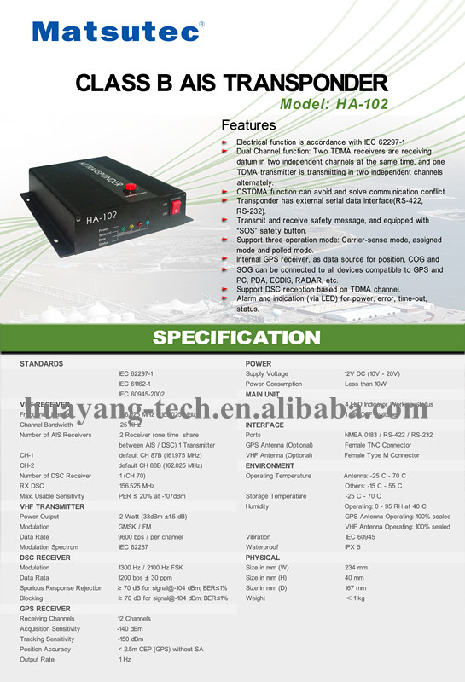

Matsutec HP-33A 4.3" marine GPS AIS transponder
FOB Price: | Get Latest Price
Min.Order Quantity: | 1 Set/Sets
Supply Ability: | 300 Set/Sets per Month
Port: | Shenzhen
Payment Terms: | T/T,Western Union,MoneyGram
Contact Supplier
Leave Messages
- Start Order

- Add to My Favorites

You May Like

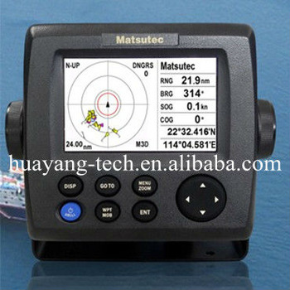

See larger image

- Product Detail

Report Suspicious Activity

Quick Details
- Type: AIS transponder combo with GPS
- Use: Other
- Screen Size: 4.3 inch
- Place of Origin: Guangdong, China (Mainland)
- Brand Name: Matsutec
- Model Number: HP-33A

Packaging & Delivery
Packaging Details: | cartons
Delivery Detail: | Within 1-2 weeks

Specifications
color LCD AIS transponder, AIS/GPS, AIS transponder, AIS display transponder, AIS/GPS transponder, AIS receiver, class B AIS
Matsutec
HP-33A
4.3" color LCD diaply AIS transponder combo with GPS navigator

The HP-33A is a class B AIS transponder for Non-SOLAS vessels such as pleasurecraft, work-boat, fishing boat etc small boat.
Special design Watching dispaly to monitor Fishing net buoy, friendly ships etc. External Alarm for MOB and Collision-Risk management.

Feature

To AIS
1. Detail Target list and Radar overview
2. Watching disaply to monitor important subject, example: Fihsing net buoy, Friend ship etc
3. External Alarm (Buzzer)
4. Low cost, reduced size and easy installation make the HP-33A ideal to meet your budgets and demands of owners and vessel operators

To GPS
1. 4.3" Sunlight Viewvable color LCD (Brightness: 500 cd)
2. GOTO track navigation
3. Stores up to 10,000 marks/ waypoints, 100 routes and 3,000 track points
4. Delicated Man Over Board Button (MOB)
5. Support NMEA 0183 ver 2.0
6. 7 display modes available, including 2 user-customized modes
7. SBAS capable for better measurement

Equipment list ( standard):
1. Dispaly unit HP-33
2. Antenna unit HA-017 with cable 10m
3. Power canle, 2m
4. Standard spare parts and installation material
5. Operator manual

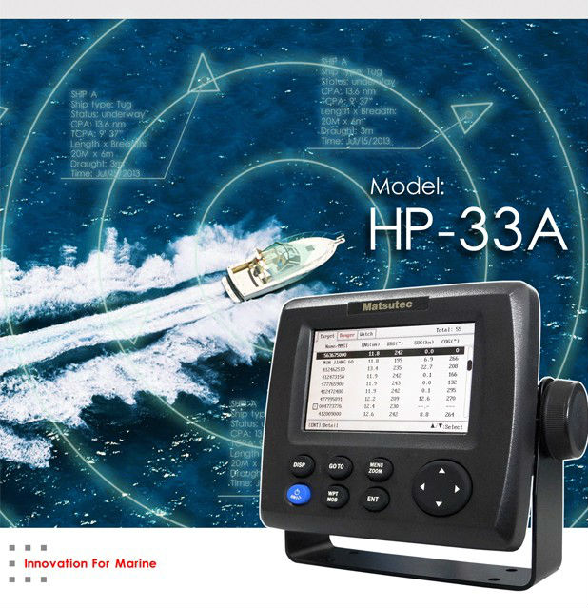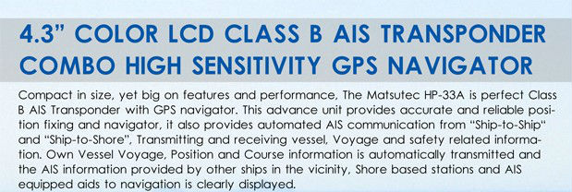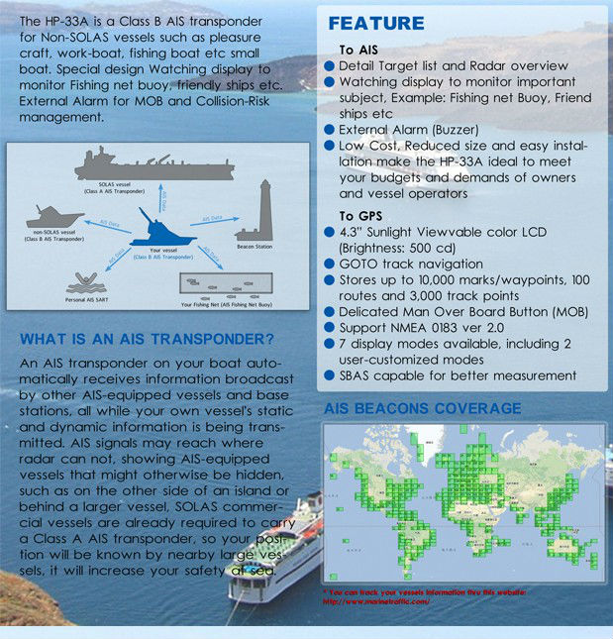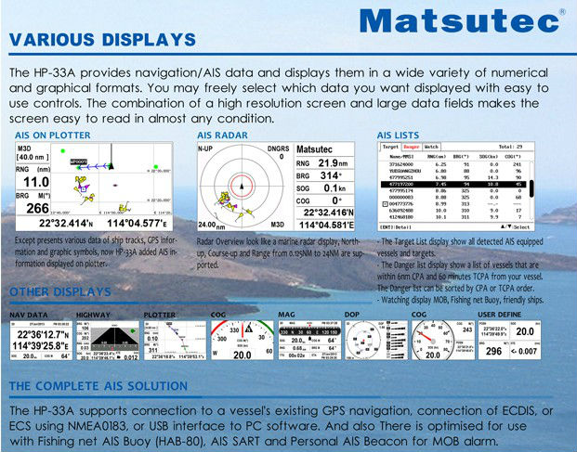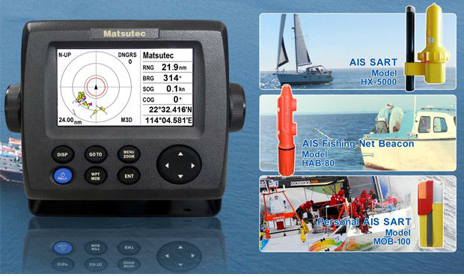
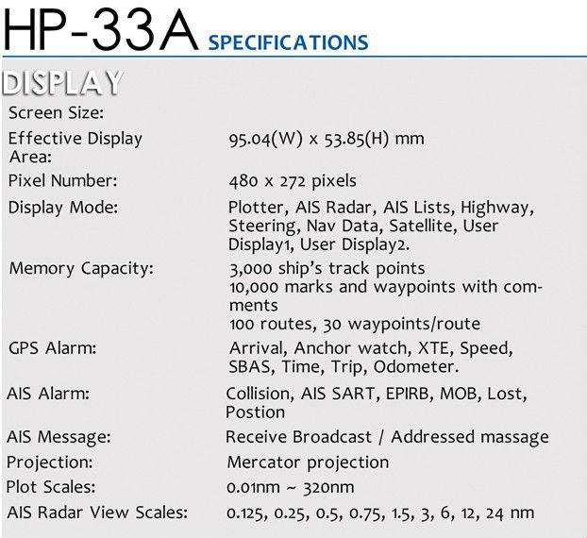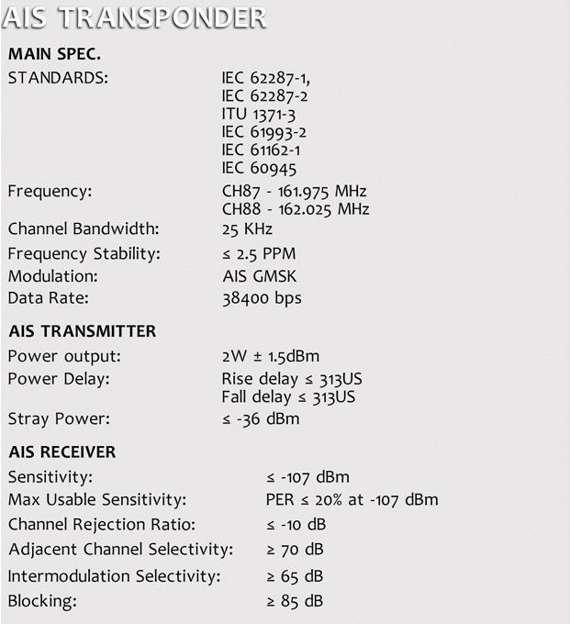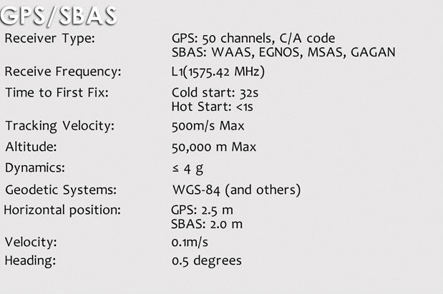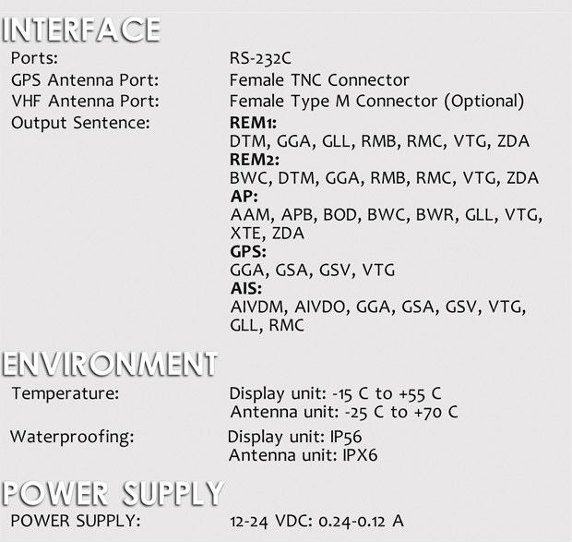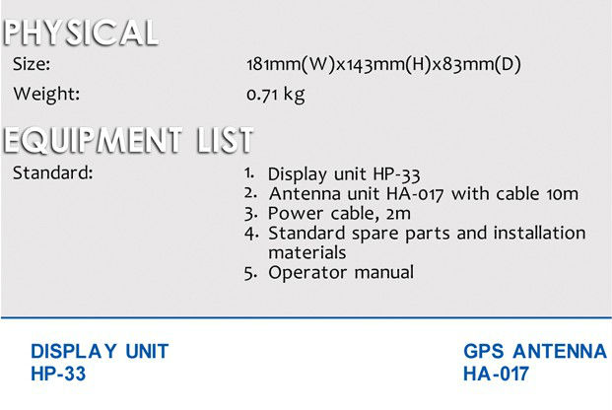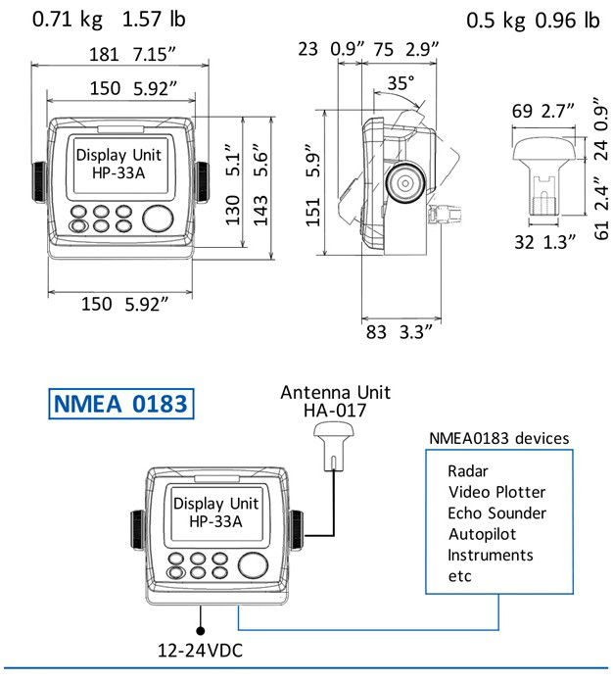
Buyer | Product Name | Price | Quantity | Order Time(GMT+8)
Go to Page Go

Email to this supplier
From:
To:
Ms. Susan LiaoLeave Messages

Your message must be between 20-8000 characters
Message:

Recommend matching suppliers if this supplier doesn’t contact me on Message Center within 24 hours.AliSourcePro

Quantity Needed:
Send

Related Products
- 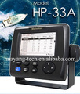
HP33 marine gps navigation ais tran...
- 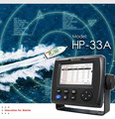
marine ais transponder
- 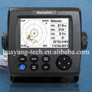
Matsutec HP-33A 4.3" marine GPS AIS...
- 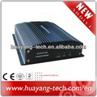
ClASS B AIS Transponder
- 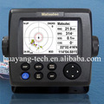
marine AIS transponder transmitter ...
marine AIS receiver and transponder...
Matsutec 4.3" color LCD class B AIS...
4.3" color LCD dispaly marine GPS/A...
Matsutec HP-33A 4.3" LCD class B AI...
marine AIS class B transponder with...

Related Keywords
- ais transponder
- high quality ais transponder
- matsutec hp-33a
Verified Supplier - Shenzhen Shenhuayang Electronic Technology Co., Ltd.
China (Mainland) | Contact Details

Experience:
Established 2009

Performance:
Quick Response Rate
Company Feedback
Resolved Unresolved Substantiated complaints against this supplier in last 90 days.

Product Showcase

Product Categories
- Compass
- BNWAS
- NAVTEX
- EPIRB
- Antenna
- LRAD
- AIS System
- fish finder
- GPS&Plotter
- Radar
- CB Transceivers
- AntennaTuner
- GPS Antenna
- Satellite Terminal
- Others
- Ungrouped

Main Products
- 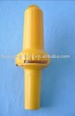
AIS SART for distress boat
- 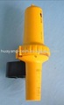
AIS SART for distress boat
AIS SART
AIS SART for distress boat
ClASS B BOAT AIS SYSTEM
ClASS B BOAT AIS SYSTEM
ClASS B AIS SYSTEM
ClASS B AIS SYSTEM BOX

Communicate with Supplier
What can I do for you?
Get Latest Price
Contact Supplier
Leave Messages

Browse by:Manufacturers - Wholesalers - China Gold Suppliers - All Products - Countries - Importers - Buying Leads - China - India - UK - Australia
Language Option:Español - Português - Deutsch - Français - Italiano - Pусский - 한국어 - 日本語 - اللغة العربية
Alibaba Group: Alibaba China - Alibaba International - AliExpress | Taobao Marketplace | Tmall.com | eTao | Juhuasuan | Alibaba Cloud Computing | Alipay
Product Listing Policy - Intellectual Property Policy and Infringement Claims - Privacy Policy - Terms of Use
Copyright Notice © 1999-2014 Alibaba.com Hong Kong Limited and licensors. All rights reserved.

