Aith
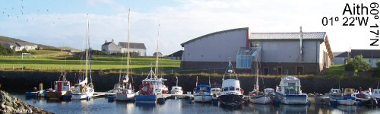
Facilities:
Fresh water, electricity, telephone, shop, post office, leisure centre, swimming pool, lifeboat station, coastguard station, waste reception, waste oil disposal, launching slip, repairs and chandlery, engineering service, boating club, pub/bar, bus service,
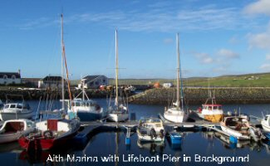
Aith has a marina built in the early 1990s with 2 visitor berths; however if these are taken, the public pier provides a first class berth. The pier is accessible at all states of the tide and provides good shelter from all wind directions. Shower facilities can be found at the Leisure Centre, a short walk from the pier.
Aith is also the most northerly lifeboat station in Britain with one of the most modern RNLI lifeboats, a 17 metre, long-range ‘severn’ class boat. The Rankin Lounge is open at weekends and the area holds a regatta every year.
Depth: | 1.2 metres max.
Contact: | Victor Gray, 01595 810 378  vaara@tiscali.co.uk

Baltasound
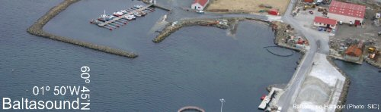
Facilities:
Toilet, shower, fresh water, fuel, telephone, shop, accommodation, leisure centre (2 miles), swimming pool, waste reception, launching slip, engineering services, boat yard, boating club, pub, taxi service.
Baltasound is a large and well-serviced harbour sheltered by the isle of Balta, across the mouth of the sound and by the high ground to the north and west. While the marina is not suitable for most visiting yachts a very convenient pontoon berth situated west of the main pier is accessible in all states of the tide, there is also a suitable anchorage south west of the pier.

Local Services
- Fuel and the toilets and shower key can be arranged through Alex Sandison & Sons Ltd (01957 711444).
- General merchants: Skibhoul Stores and a Post Office, 1 mile away (01957 711304) and H Henderson, 1.5 miles away (01957 711411).
- A & W McLeod offers a taxi service, as does P & T Coaches (01957 711666) who also run a bus service and car hire.
- Repairs can be carried out by Unst Inshore Services (01957 711811).
During the summer the harbour is host to various events including a regatta and fishing competitions as well as music evenings in the hall.
Depth: | 5 metres max.
Charges: | See table in link Yachting Charges
Contact: | Ian Mackay , 07772230754
Rounding Muness, on the south-eastern corner of Unst, Skuda Sound leads to the exposed anchorage of Uyeasound, where there is a small dock (only accessible at high tide), toilets, telephone, a youth hostel and an annual regatta.
Basta Voe, a former naval anchorage is a good place to see Otters at dawn and dusk. Recent excavations have also uncovered an Iron Age settlement at the Tafts of Bayanne, by Sellafirth.

Bressay
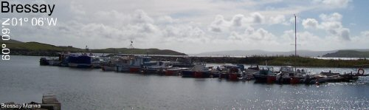
Facilities:
Toilets, fresh water, electricity, telephone, shop, post office, waste reception, launching slip.
While the convenience of the pontoon and all Lerwick’s facilities may seem more than ideal Shetland has so much more to offer those travelling by sea. Half a mile across the harbour, the island of Bressay offers a visitor berth in the marina at the Voe of Leiraness where there is no problems with access and good shelter. The Maryfield Hotel has good pub-grub and the island offers some fine hill and coast walking. There is also a secluded anchorage in the North of the island at Aith Voe.
Depth (Low water): | 2 metres
Charges: | No charges for overnight berthing
Contact: | Tom Mainland, 01595 820 284
East of Bressay is the National Nature Reserve island of Noss, which has a day time anchorage at Nesti Voe. Arriving at Noss by boat is one of the most spectacular wildlife sights anywhere - millions of years of wind and ice have burrowed thousands of nesting ledges in the sandstone cliffs which stretch a mile long. At the peak of the breeding season the stupendous chorus of around 150,000 birds and chicks is unforgettable - as is the smell of the guano which stains the cliffs white!
Warning: The bird cliffs on the east side of Noss are just off the edge of the detailed chart and, although the water is mostly deep, there are several dangerous uncharted reefs - so yacht skippers should take local advice before approaching the cliffs by sea.

Burra

Hamnavoe
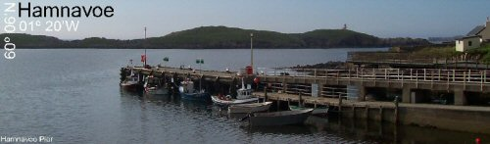
Facilities: Coming soon.
Hamnavoe has a small pier and is an ideal base to explore the nearby uninhabited islands of Oxna, Papa, Cheynies and Hildasay. The pretty fishing village, overlooks the sheltered inlet of Hamna Voe, protected from the open Atlantic by the arm of Fugla Ness and its lighthouse.
Depth:
Charges: | See table in link Yachting Charges
Contact: | Terry Scott, 01595 859444

Bridge End
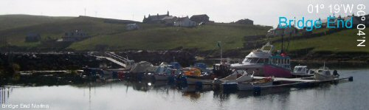
Facilities: fresh water on pier, electricity on pier on arrangement, waste reception, slip, nearest shop and post office - Hamnavoe (2 miles).
Bridge End Marina is situated at the head of South Voe; while there are no problems in entering the marina there are shoals in the voe which should be avoided. The Outdoor Centre, a converted school and school house, costs £15 for day use offering toilets, showers, telephone, and laundry.
Depth: | 1 metre max.
charges:  Contact: | £6 per week  Jim Anderson, 01595 859332, or Bobby Hunter, 01595 859270

Burravoe
01° 02'W, 60° 29'N
Facilities:
fresh water, electricity, fuel on arrangement, waste reception, launching slip, (shop, leisure centre, swimming pool, bar - available at pier, ¾ mile from marina)
Burravoe, at the southern tip of Yell, is a land-locked anchorage with glorious walks, particularly around Heoganess, which shelters the harbour, operational since the 1500s. The area provides three options; the pier, the marina or to anchor in the excellent holding ground at the head of the voe. Access poses no problems for most visiting craft, however, anything over 3 metres should take care in the entrance of the voe.
The area holds an annual sailing regatta. The Old Ha' museum and heritage centre has fascinating exhibitions, for example the Bobby Tulloch photographic archives, as well as serving a great cup of tea with home bakes. The centre of the village is St Coleman’s Episcopal Church, a pretty building which adds a lot to the general feel of the area.
 | Pier | Marina
Charge: | £12 per visit | £5 per visit
Contact: | Dan Thompson, 01957 722 201 | Robert Odie, 01957 722 315
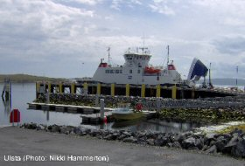

Collafirth
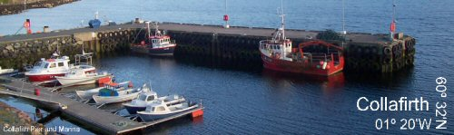
Facilities:
Fresh water, telephone, waste reception, launching slip, bus and taxi service.
Yell Sound is good cruising water and has secluded bays at Southladie Voe, Burra Voe, and North Collafirth. The marina and pier are situated at Saltoo, Collafirth built in 1988 on the site of an old Norwegian whaling station where the fishing industry lives on. Electricity can be arranged at the marina and approach poses no problems in all states of the tide.
 | Marina | Pier
Depth: | 2 metres max. | 9 metres max.
Charge: | £2.50 per day | See table in link Yachting Charges
Contact: | David Laurenson, 01806 533 288 | John Peter Blance, 01806 544296
Further south are Queyfirth, Ollaberry and Gluss Voe which also provide good shelter. Yell Sound's north eastern shores are bleak and rocky, the only shelter being at Whalfirth (small pier at the head). Tide races skirt Gloup Holm and the northern end of Bluemull Sound.
Sullom Voe has anchorage at its head, on the north side of Brae, and in Garths Voe. It is a long, very sheltered sea loch noted for its wildlife, particularly otters, seals and sea ducks. Despite the huge oil terminal at its eastern end, handling some of the largest tankers in the world, Sullom Voe remains one of Shetland’s most tranquil and unspoilt sea lochs.

Cullivoe
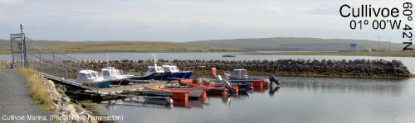
Facilities:
Toilets, fresh water, fuel, telephone, shop, post office, waste reception, waste oil disposal, slip, repairs and chandlery, boat hoist (crane truck for hire), engineering services, bus service, car hire, taxi service.
Cullivoe in North Yell lies on the western shore of Bluemull Sound. The harbour, built in 1991, remains the most active on the island and is accessible in all states of the tide, sheltering both a pier and marina.
It makes a good base for exploring the rest of the island, especially with R.G. Jamieson and Son’s taxi service based nearby (01957 744214), as well as one of the most obliging shopkeepers in Britain – R. S. Henderson, who also sells marine diesel (01957 744248). The Pier also becomes a party venue during the first weekend of July when ‘Party at the Pier’ is celebrated.
 | Pier | Marina
Depth: | 6.0 metres max. | 1.2 metres max.
Charge: | See table in link Yachting Charges | £5 per day
Contact: | Trevor Henderson, 07887867809 | Andrew Nisbet, 01957 744262
The area can be hazardous in a northerly wind during the winter months and although Yell Sound is excellently charted, north of Cullivoe there are many inshore rocks on the west coast of Unst, not all of which are accurately charted. Visiting craft should give this rock-bound coast a berth of at least two cables unless with a local pilot on board.
A cruise past the West shores of Unst will pass by Lunda Wick, overlooked by the ruined 12th Century St Olaf’s Kirk with the tombstones of two German merchants and of Thomas Mouat, who built Belmont.
Hermaness Natural Nature Reserve in north Unst is one of the wonders of the bird world. The gannetry extends onto the Muckle Flugga stacks. Beyond is the Out Stack, the full stop at the end of Britain. Extraordinary caves and natural arches buttress the eastern shore of Burrafirth, a spectacular anchorage but unsafe in northerly winds. The SNH Visitor Centre, based in the lighthouse shore station at Burrafirth, provides a great opportunity to learn more about the Harmaness NNR (01957 711278). Scribble
On the north east coast of Unst, Wick of Skaw, Norwick, and Haroldswick offer temporary shelter. Haroldswick is home to the Unst Boat Haven, Shetland’s only museum dedicated to the history of the island’s distinctive wooden boats and the line-fishermen who used them until the early 20th century. Also well worth a visit is the fascinating Unst Heritage Centre, where the permanent displays include geology, geneaology and the island's famous fine lace knitting and spinning. Both centres are open daily, 2.00pm to 5.00pm, May to September.
Next door, the Haroldswick shop has a do-it-yourself cafe, and around the corner you can have your postcards franked at Britain's most northerly post office. On the eastern side of the village, Britain's only working talc mine is at Clibberswick, known also for its Viking soapstone quarry

Fair Isle
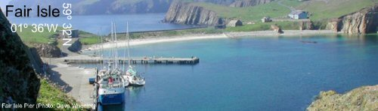
Facilities:
- Toilets, showers, fresh water, food and drink, telephone (all available 300 metres away at the bird observatory).
- Waste reception (on pier).
- Shop and post office (2 miles).
Fair Isle, world-famous for its knitting and bird life, has a well sheltered and easily accessible pier at North Haven. There is no all-weather anchorage but the North Haven and the South End are suitable for summer cruising (advice should be sought). It makes a great stepping stone, whether on the way North to Shetland or to the South to explore the rest of Britain.
Fair Isle’s internationally acclaimed Lodge and Bird Observatory sits around 300 metres from the pier and has toilets, showers and a telephone as well as serving excellent food. The island lies in the flight paths from Scandinavia, Iceland and Faroe making it famous for the massive numbers of visiting species both common and rare. From April to August the cliffs are busy with the sound of thousands of fulmars, kittiwakes, razorbills, guillemots, black guillemots, gannets, shags and puffins, while skuas and terns fiercely defend their nests on the moorland.
Grey and common seals are frequently seen, with harbour porpoises mostly sighted in summer. Whales and dolphins sometimes cruise close inshore, white beaked Atlantic white sided dolphins, killer whales (orcas) and minke whales are often spotted from the mail boat "Good Shepherd" on passage to and from Shetland.
The George Walterson Memorial Centre and Museum in the former Fair Isle school on the south of the island is packed with displays of the island’s history from prehistoric times to the present. Fair Isle is also famous for its knitting: the only source of the genuine Fair Isle garment is the island. A small island cooperative, Fair Isle Crafts, produces quality knitwear labelled with Fair Isle’s own trade mark.
Depth: | 5 metres max.
Charge: | No charges
Contact: | Jimmy Stout, 01595 760222

Foula
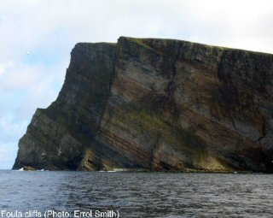

Lying 15 miles west of the Shetland Mainland is Foula. The island has no safe all-weather anchorage but the harbour at Ham Voe has been improved and there is also the option of taking the ferry from Walls. The population of around 40 people is greatly outnumbered by the islands seabird colony thus the name, deriving from the Norse fugl ey (meaning ‘bird island’). It is dominated by its sheer cliffs, which reach their peak at The Kame (1,220 ft), Britain's second highest sea cliff after St. Kilda. The Hoevdi Shoals, where the White Star liner 'Oceanic' foundered, lie east of Foula.
Facilities:
Toilets and telephone (1 mile away at the airstrip), fresh water, waste reception.
Charge: | No visitor charges
Contact: | Kevin Gear, 01595 753235

Lerwick
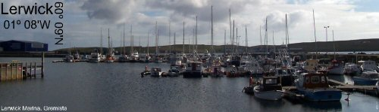
Facilities:
Toilets, showers, fresh water, electricity, fuel, telephone, laundry, disabled facilities, internet access, shop, post office, accommodation, leisure centre, swimming pool, lifeboat station, coastguard station, waste reception, waste oil disposal, launching slip, repairs, chandlery, boat hoist, engineering, boating club, food and drink, bus service, taxi service, car hire, cash point.
Lerwick Port Control keeps a 24-hour watch on VHF channel 12 and visiting craft should contact the duty controller on that channel before entering the harbour.
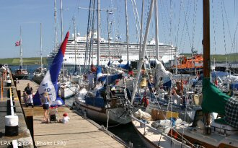
The capital of Shetland, Lerwick, is the main centre for visiting craft - and usually the first port of call. It invites boats right in to the heart of town: A 70 metre floating pontoon situated just across the road from the town centre can accommodate up to 70 boats and provides excellent shelter right through from May to September.
This bustling town has all you need when making a Shetland landfall - a Tourist Information Centre, Customs, a Coastguard station, helpful staff at Lerwick Port Authority, ship chandlers, supermarkets, licensed grocers specialising in marine supplies, a leisure centre and swimming pool, as well as the several high quality restaurants, cafes and bars scattered throughout the town. If you have a problem, there’s a shipyard, skilled repair engineers and a lifeboat station.
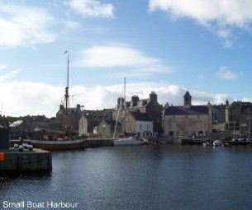
Just a step along from the small boat harbour at Victoria Pier is the Lerwick Boating Club (01595 692407), where visiting crews are always welcome to take a hot shower, use the laundry and enjoy a drink at the cheerful bar - with a lovely view of the harbour. The key for the club’s showers, toilets and laundry is usually available by arrangement from the Lerwick Port Authority Office at Albert Building on the Esplanade.
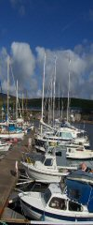
The club runs a busy summer programme of sailing races for dinghies and the famous 'Shetland Model' skiffs. Visitors are welcome as spectators or participants.
The Marina is available for longer stays and subject to availability visitor berthing may be organised with the Marina Users Association. It is situated at the North end of Lerwick Harbour about 2km from Lerwick town centre. It is run by a community group and may have vacant berths for temporary stays. Each pontoon is operated by a security gate and has water and electricity supplies available. On the south side of the pier the slipway can take vessels of up to 2m draft to dry out for emergency repairs, a boat hoist is also available for emergency lift out of visiting boats. Car and trailer parking is available just outside the marina and facilities are available locally for winter storage of boats ashore.
 | Small Boat Harbour Pontoon
Depth (Low water): | 8 metres (mouth of dock)  1.2 metres (inner corner)
Charges: | £0.50 per metre per day  (minimum charge £4.00)
Contact: | Lerwick Port Authority, 01595 692991 or VHF Channel 12

 | Lerwick Marina, Gremista
Depth (Low water): | 2.5 metres (outer pontoons)  1.8 metres (inner pontoons)
Contact: | Bert Anderson 01595 693537

Mid Yell
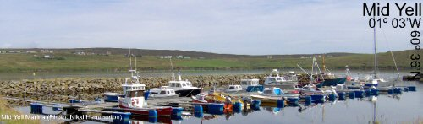
Facilities:
Toilets, electricity, shop, post office, leisure centre, swimming pool, waste reception, boating club (open 7pm-1am Friday & Saturday), bar, car hire, taxi service.
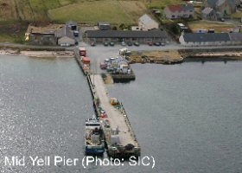
Mid Yell has a large pier and a marina which has room for 1 larger or 2 smaller boats; when entering, boats should keep close to the breakwater but risk of damage is low as the bottom is sandy. You can usually find a berth at the pier but it is used round the clock by fish farms so the marina or anchor might be the better option. The deep voe is sheltered by the uninhabited island of Hascosay, said to have magical, mouse deterrent soil!
Staff at the Linkshouse Shop and Post Office (1 mile away) are extremely friendly and helpful to visiting yachts – and stock an amazing range of goods, from mops and buckets to bacon rolls and home-grown Yell strawberries (01957 702026). A fishing competition is held in the second week of August, a regatta in the first or second week in September and an agricultural show in East Yell in the first week of September.
Mid Yell is the best base for exploring the east coast of Yell and the neighbouring island of Fetlar, famous for its Snowy Owls, Phalaropes, Puffin colonies and the seal nurseries of the Blue Banks. There is daytime anchorage only in Fetlar, at the Wick of Gruting and Wick of Tresta. An old pier at Houbie ebbs up badly but there is a new ferry pier at Oddsta in the north end of the island. Further South along the East coast at Otterswick is a moulding of a figure head known as ’Da White Wife‘ from the 1924 wreck of the German training ship the ‘Bohus’.
 | Pier | Marina
Depth: | 1.5 metres max. | 2.0 to 3.5 metres
Charge: | See table in link Yachting Charges | £5 per week
Contact: | Roger Moore, 01806 244200 | Angus Petrie, 01957 702 317

Out Skerries
00° 45'W, 60° 25'N
Facilities:
Toilets, showers, fresh water, fuel by arrangement, telephone, disabled facilities, shops, post office, waste reception, slip.
The trip to Out Skerries by yacht provides an ideal opportunity for spotting minke whale and harbour porpoise as well a great vantage point for viewing the dramatic coastline which encompasses an impressive collection of cliffs, arches, blow holes, stacks, voes and beaches.
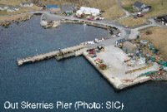
Out Skerries has a marina, pier and a fine sheltered anchorage in the natural harbour of Böd Voe even in the full force of North Sea storms. The facilities are good and the pier also has electricity additional to those listed above. Standing around 9 miles East of Shetland it also makes the perfect starting point for the 164 nautical mile onward voyage to Norway or the continued Shetland tour onto Whalsay.
The dramatic scenery, historical interest, outstanding wildlife and, not least, the warm welcome from the over 70 inhabitants make a visit to this mini-archipelago unforgettable. Skerries are Shetland in miniature - famous for migrating birds and for 17th century treasure - the wrecks of two Dutch East Indiamen.
There are two shops on the isles, the West Isle Shop (01806 515297), and Alex Humphray & Co. (01806 515226). For a real flavour of Skerries life, make your visit coincide with the annual eela (rod-fishing) competition in July or the yacht race in August which also feature music, dancing, eating and drinking at the hall where you will be made more than welcome.
 | Marina | Pier
Depth: | 3 metres max.
Charge: | £2 per night | See table in link Yachting Charges
Contact: | Denise Anderson, 01806 515272 | Roger Moore, 01806 244200

Papa Stour
Papa Stour’s sea caves are some of the best in Britain and are a Special Marine Area of Conservation: the island’s volcanic formation has been eroded to form an amazing coastline of stacks, arches and caves, most spectacular of which is Kirstan‘s Hole – however you’ll need a very calm day and a rubber boat to explore them properly. There is visitor berthing available at the old pier in Housa Voe as well as good summer anchorages in Hamna Voe, Culla Voe, and West Voe. The island is rich in history and has substantial populations of skuas, auks, and terns.
The cliffs between Walls and Sandness are wild, beautiful and fringed with reefs, not all of them well-charted close to the cliffs (perhaps because the 19th century Royal Navy surveyors reasoned that no-one would ever be crazy enough to sail that close!) The tide race between Sandness and Papa Stour is fierce and can be dangerous. In rough water more turbulent water lies between Papa and the Ve Skerries to the north west.
Facilities:
Toilets, fresh water, telephone (1/2 mile), waste disposal, launching slip.
Depth: | 3 metres max.
Charge: | £7.17 per four day stay
Contact: | Roger Moore, 01806 244200

Scalloway
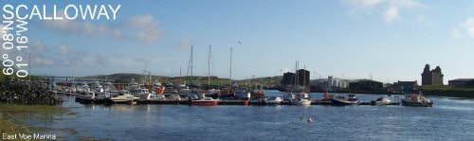
Facilities:
Toilets, fresh water, electricity, fuel, telephone, shops, accommodation, swimming pool, waste reception, engineering services, electrical repairs, boat yard, boating club, food and drink, taxi service, cash point.
Scalloway, the ancient capital Shetland until the 17th century, provides a storm-proof harbour and everything a visiting boat requires. The harbour is sheltered from all wind directions by Trondra and Burra and can be accessed at all states of the tide. When arriving in Scalloway the main place to berth is the Scalloway Boating Club pontoon at Port Arthur, but the area offers 3 alternatives: the marina at Port Arthur, the marina at the head of the East Voe and the main pier, Blacksness.
Approaches and harbour are well lit with various navigational aids to make entry and departure safe and easily navigable.
For the most accessible onshore facilities including toilets, showers and laundry visit the boating club, open Monday - Thursday 7pm till late, Friday 3pm till late and Saturday - Sunday 9am till late. For waste oil disposal visit Blacksness Pier and the handy pontoon berth for fuel and ship chandlery.
The Scalloway Boating Club pontoon and the Port Arthur Marina are particularly handy with the Boating Club, which extends a legendary welcome and holds an annual regatta, and Da Half restaurant which provides fine filling portions.
On the main street a charming little museum depicts the saga of the wartime 'Shetland Bus’ operation based here from 1942 - 1945, when Norwegian fishing boats which sailed to Shetland from German-occupied Norway, bringing refugees to safety and returning with ammunition and resistance fighters.
Also on the main street is the family run Scalloway hotel which offers a menu featuring locally caught seafood and local produce. As well as well stocked shops, a post office, a butcher, and hairdressers.
The illegitimate son of King James IV, Robert Stewart, became Earl of Orkney and Shetland in the late 1500s. He died in 1593 and was largely unmoored due to his corrupt rule disregard to local laws and traditions. He was succeeded by Earl Patrick Stewart who was no better and was executed for treason in 1615. During his reign he had slave labour build the Scalloway Casle, the four storey main block and a wing of which still remains and dominates the harbour. Inside a display explains its history.
Scalloway is also the best base for visiting Law Ting Holm, the site of the Parliamentary gatherings or ‘law tings’ during the 12th and 13th century. Situated on an islet at the North end of Tingwall loch linked to the shore by a causeway, around 3 miles inland from the village.
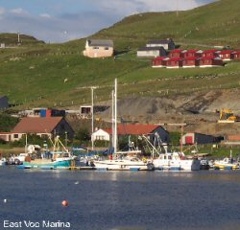
   | East Voe Marina
  Charges:
  Contact: | Eddie Sinclair, 01595 880476
 | Blacksness Pier
Depth: | 70 to 4.8 metres,  3.5 metres at low level quay.
Charges: | See table in link Yachting Charges
Contact: | Harbour Office 01595 744221  scalloway.harbour@  shetland.gov.uk  VHF Channel: 9, 12, 16, Duty Harbour Master / Port Control, 01806 242551

 | 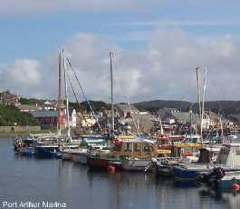
   | Port Arthur Marina
  Depth: | 5-2 metres
  Charges: | No charge for overnight, £7 per week
  Contact: | Hamish Jamieson, 01595 880649, or Scalloway Boating Club
 | Boating Club Pontoon
Depth: | 4 metres max.
Charges: | Donation to club
Contact: | Boating Club, 01595 880388

Skeld
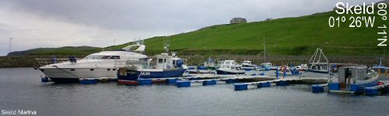
Facilities:
Toilet, shower, fresh water, electricity, fuel, telephone, laundry, post office, waste reception, bus service, taxi service.
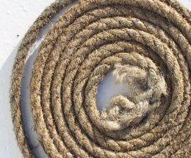
Skeld is a landlocked haven with an excellent pier and new marina. There are 8 visitor berths as well as a floating pontoon with space for another 20+. When entering the narrows of Skeld Voe keep centre then point towards the church - avoid shallow water on the west side of centre line.
For a real taste of Skeld hospitality schedule your trip for the third week of July (approx.) when the annual regatta is held encompassing rowing, yachting, fishing and socialising.
The village is home to a smokehouse, producing a wide range of seafood and a bus service leaves for Lerwick at 0745 hrs and 1320 hrs returning from Lerwick at 1705hrs.
Depth: | 2.5 metres max.
Charge: | £10 per week
Contact: | James & Josephine Scott, 01595 860287
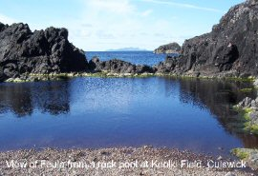
Further West are two of the most exquisite bays in Shetland: Westerwick and Culswick, each a narrow green valley ending in a pebble beach fringed by sea stacks, cliffs and caves.
At the time of writing (2005) there is also a marina planned in Gruting voe.

Symbister, Whalsay
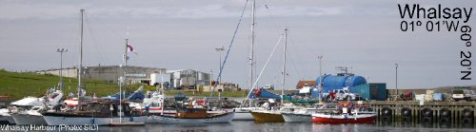
Facilities:
Toilets, showers, fresh water, electricity, fuel, telephone, shop, post office, accommodation, leisure centre, swimming pool, waste reception, waste oil disposal, repairs and chandlery, engineering services, boating club, restaurant, pub/bar, taxi service.
In Whalsay, Symbister is a handy stopover for cruising yachts sporting both a marina and pier, as well as a suitable anchorage in North Voe, providing shelter from South Westerly winds. While the marina may not have a berth, the pier offers first class berthing for up to around 20 visiting boats. The area is a busy fishing harbour so yachts should be careful not to interfere with normal harbour traffic; particularly during August when the Outer Basin is occupied by pelagic trawlers. The approach is clear and well lit, however fairly strong currents both North and South of the entrance should be noted.

Local Services
- Boating Club open most lunch times and evenings, welcomes visitors.
- Shops, J.W.J Ltd. (01806 566451) and Tetley & Anderson - also a post office (01806 566585).
- A museum devoted to the German Hanseatic traders who once dominated the Shetland economy.
- Taxi service (01806 566511) and engineering services, Ian Irvine (01806 566627).
- Leisure centre five minutes walk inland.
- Family run restaurant and pub, Oot Ower Lounge open 11am till 1am (evening meal must be booked).
- Britains most Northerly 18 hole golf course in the furthest North corner of the isle.
- The regatta week, held in the last week of July, guarantees a good time to be held by all.
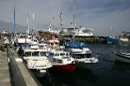
The surrounding waters are yet another good place for spotting porpoise, dolphins, and keep a keen eye and you might see why the Vikings called it “Hvals-Oy” - the island of whales.
Depth: | Inner Basin: 5m, Outer Basin: 7m.
Charge: | See table in link Yachting Charges

Vidlin
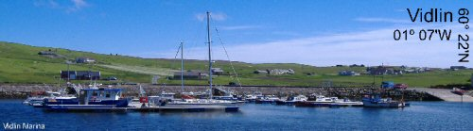
Contact: Bobby Sutherland, 01806 566382
Facilities:
Toilets, fresh water, electricity, telephone, waste reception, shop, post office and launching slip.
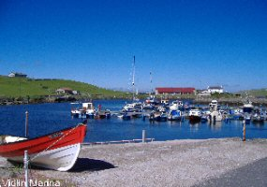
Vidlin marina provides good shelter from a southerly wind and is accessible in all states of the tide. It sits at the head of the voe forming the centre of the village where a pretty cluster of houses wrap their way round. There is a well stocked shop, J.I. Herculson, situated at the cross roads to Lunna and Swinning (01806 577285) and the toilets are situated at the Out Skerries ferry terminus 200 yards along the west shore.
Lunna House is also nearby - rich in history, it acted as the headquarters for the Norwegian resistance movement during the Second World War. It looks down on the old Kirk of Lunna, one of the oldest kirks in Shetland.
Depth: | 1.75 metres max.
Charge: | No charge for short term berthing
Contact: | Johnny Johnson, 01806 577 326
South Nesting Bay leads into the perfect little anchorage of the Dock of Lingness, where yachts drawing less than 2 metres can ride out any summer storm.
The beautiful Isles of Gletness guard the entrance to Catfirth, where the anchorage was used by flying boats in the First World War.

Voe
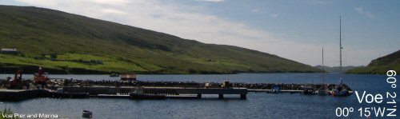
Facilities:
Toilets, showers, fresh water, electricity, fuel, telephone, shop, launching slip, food and drink, bus service.
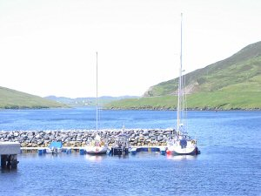
Voe, the most Norwegian-looking village in Shetland, nestles at the head of the deep, sheltered, sea loch of Olna Firth and offers a newly revamped pier and marina. The approach is narrow and a productive mussel farming area so care is advised.
The traditional part of the village lies along the waterfront; the Pierhead, a wood-panelled pub/restaurant fully captures the essence with a real fire and occasional live music as well as offering the very best in traditional ales, wines and spirits as well as food prepared from the freshest, local produce (01806 588332).
Joinery and welding workshops are available and Johnson & Wood, Voe Bakery is also situated on the waterfront (01806 588245). A shop, Tagon Stores (01806 588286) and play park are situated on the main road up the hill from the pier.
Depth: | 3.75 metres max.
Charge: | TBA
Contact: | Keith Robertson, 01806 588 708
Brae, at the head of Busta Voe, has a shop, post office and good facilities for visitors at Busta House Hotel, the Brae Hotel, the Mid Brae Inn and the Delting Boating Club. There is also a heated swimming pool at the North Mainland Leisure Centre and the area holds an annual sailing regatta.
The cruise around Muckle Roe will reveal the beautiful small inlets of the Hams of Roe, particularly North Ham edged with huge red cliffs, stacks and a natural arch. A cruise up the west side will take you through St. Magnus Bay where the Atlantic Ocean has battered the land into a scene of astounding beauty. To the north, the Isle of Nibon is a noted beauty spot and Hamar Voe is one of Shetland's few natural year-round anchorages.
Hillswick and Ura Firth are open to the south but safe enough for overnight summer anchoring, to enjoy a meal and drinks at the The Booth, one of Shetlands oldest buildings - now a vegetarian cafe as well as supporting a seal rescue centre in the back garden (01806,503348).
The cliff coast from Hillswick Ness to Uyea Isle is sensational. The Drongs stacks and the Dore Holm lead on to the basalt cliffs of the Skerry of Stenness, where there is a huge, square cave. Spectacular blow holes, The Holes of Scrada, stretching 132 yards inland were created when the roof of a deep and narrow sea cave collapsed are also not to be missed.
Further on is the Grind o’ da Navir (Gate of the Borer), where the sea has carved a huge, vertical sided gateway into the cliffs and thrown it inland.
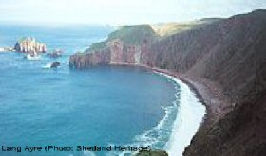
North of Eshaness lighthouse is another Hamnavoe (meaning - the safe harbour). Ockran Head opens Shetland's longest sea loch, Ronas Voe, with an excellent anchorage at the head, overlooked by Shetland’s highest hill, Ronas Hill (standing at 1477‘) which is home to around 15 varieties of arctic flowering plant. Also en-route, west of Ronas Hill are the huge red cliffs and the Lang Ayre, Shetlands longest beach.
Fethaland was once Shetland’s busiest ‘haaf’ station, where traditional open rowing boats (sixareens) would return laden with fish after being out in the open sea (far haaf) for days on end. Sixty sixareens were based here and the ruins of twenty lodges still stand.
The gaunt Ramna Stacks, an RSPB bird reserve, mark the entrance to Yell Sound and the tanker lanes into Sullom Voe. Visiting yachts should call Sullom Voe Vessel Traffic System (VTS) on VHF Channel 14 before entering Yell Sound to ensure there is no conflicting traffic.

West Burrafirth
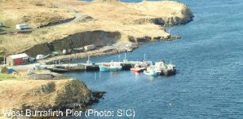

West Burrafirth makes a good anchorage featuring a pictish broch and shelters the pier for the Papa Stour ferry, currently being renovated (2005). To the east lies uninhabited Vementry Isle and the sound of Swarbacks Minn, the entrance to Aith Voe, Olna Firth, and Busta Voe - a former naval anchorage. As you enter, look up towards Vementry’s First World War watch tower and two gun emplacements which guard the sound. The Isle also features Shetland’s best-preserved chambered cairn.
Facilities:
Toilets, showers, fresh water, fuel, telephone, waste reception, waste oil reception, launching slip.
Depth: | 4 metres max.
Charge: | See table in link Yachting Charges
Contact: | Alan Laurenson, 01595 809283

Walls
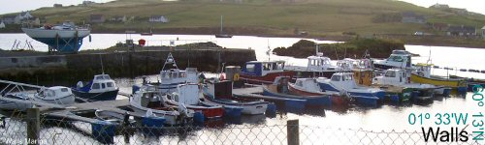
Facilities:
Toilets (at the public pier), showers, electricity, fuel (on arrangement), fresh water, telephone (at shop), shop, post office, swimming pool, waste reception, launching slip, boating club (open weekends), bus service, café
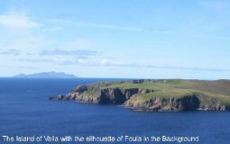
Walls lies on the south side of Shetland's West Mainland, at the head of Vaila Sound and sheltered even from southerly storms by the islands of Linga and Vaila. It has a public pier, a marina with 2 visiting berths and a second pier at the Walls Boating Club. A wide berth must be taken around Kirk-a-Skerrie, in past the public pier. Power and water are found at the public pier, which is more suitable for larger yachts. The cheerful boating club and the family run bakery and tea room are also close at hand. It is the starting point for the annual Round Foula Yacht Race as well as the Walls Regatta also held every year. Just off Vaila Sound is an award-winning restaurant, Burrastow House, where much of the food is grown on the premises in one of Shetland’s most productive gardens.
 | Marina | Boating Club | Pier
Depth: | 1.5 metres max. | 1.5 metres max. | 4 metres max.
Charge: | £5 per day for first 6 days, £30 per month thereafter | £5 per day | See table in link Yachting Charges
Contact: | John Isbister, 01595 809 311 | Andrew Tait, 01595 809 277 | Larry Inkster, 01595 809293
Vaila island has an area of around 3km2 and supports a magnificent Edwardian mansion, the largest house of its kind in Shetland as well as the ancient watch tower, Mucklaberry Castle.
The cliffs between Walls and Sandness are wild, beautiful and fringed with reefs, not all of them well-charted close to the cliffs (perhaps because the 19th century Royal Navy surveyors reasoned that no-one would ever be crazy enough to sail that close!) The tide race between Sandness and Papa Stour is fierce and can be dangerous. In rough water more turbulent water lies between Papa and the Ve Skerries to the north west.

Pleasure Craft 2011/2012
PRICE PER GT | GT |  | COST |  | VAT |  | TOTAL
(45p) |  | (£) |  | (£) |  | (£)
0.45 | 16 and Under |  | 7.53 |  | 1.51 |  | 9.04
0.45 | 17 |  | 7.65 |  | 1.53 |  | 9.18
0.45 | 18 |  | 8.10 |  | 1.62 |  | 9.72
0.45 | 19 |  | 8.55 |  | 1.71 |  | 10.26
0.45 | 20 |  | 9.00 |  | 1.80 |  | 10.80
0.45 | 21 |  | 9.45 |  | 1.89 |  | 11.34
0.45 | 22 |  | 9.90 |  | 1.98 |  | 11.88
0.45 | 23 |  | 10.35 |  | 2.07 |  | 12.42
0.45 | 24 |  | 10.80 |  | 2.16 |  | 12.96
0.45 | 25 |  | 11.25 |  | 2.25 |  | 13.50
0.45 | 26 |  | 11.70 |  | 2.34 |  | 14.04
0.45 | 27 |  | 12.15 |  | 2.43 |  | 14.58
0.45 | 28 |  | 12.60 |  | 2.52 |  | 15.12
0.45 | 29 |  | 13.05 |  | 2.61 |  | 15.66
0.45 | 30 |  | 13.50 |  | 2.70 |  | 16.20
0.45 | 31 |  | 13.95 |  | 2.79 |  | 16.74
0.45 | 32 |  | 14.40 |  | 2.88 |  | 17.28
0.45 | 33 |  | 14.85 |  | 2.97 |  | 17.82
0.45 | 34 |  | 15.30 |  | 3.06 |  | 18.36
0.45 | 35 |  | 15.75 |  | 3.15 |  | 18.90
0.45 | 36 |  | 16.20 |  | 3.24 |  | 19.44
0.45 | 37 |  | 16.65 |  | 3.33 |  | 19.98
0.45 | 38 |  | 17.10 |  | 3.42 |  | 20.52
0.45 | 39 |  | 17.55 |  | 3.51 |  | 21.06
0.45 | 40 |  | 18.00 |  | 3.60 |  | 21.60
0.45 | 41 |  | 18.45 |  | 3.69 |  | 22.14
0.45 | 42 |  | 18.90 |  | 3.78 |  | 22.68
0.45 | 43 |  | 19.35 |  | 3.87 |  | 23.22
0.45 | 44 |  | 19.80 |  | 3.96 |  | 23.76
0.45 | 45 |  | 20.25 |  | 4.05 |  | 24.30
0.45 | 46 |  | 20.70 |  | 4.14 |  | 24.84
0.45 | 47 |  | 21.15 |  | 4.23 |  | 25.38
0.45 | 48 |  | 21.60 |  | 4.32 |  | 25.92
0.45 | 49 |  | 22.05 |  | 4.41 |  | 26.46
0.45 | 50 |  | 22.50 |  | 4.50 |  | 27.00

Repairs
- A. Adamson & Co, 22 Commercial Road, Lerwick, ZE1 0LX, Tel - 01595 696656
- H. N. P. Engineers (Lerwick) Ltd, Commercial Road, Lerwick, ZE1 0NJ, Tel - 01595 692493
- Ian Irvine Engineering, Strath Haven, Symbister, Whalsay, ZE2 9AG, Tel - 01806 566627
- J.L.B Surveys, Bakkabrent, Sandwick, ZE2 9HP, Tel - 01950 431323
- Malakoff Ltd, North Ness, Lerwick, ZE1 0LZ,
Or Moores Yard, Westshore, Scalloway, ZE1 0JX, Tel - 01595 695544
- Marine Autos, Hillside, Gulberwick, ZE2 9JX, Tel - 01595 697455
- MSM Diving, Houbans, Sullom, ZE2 9RD, Tel - 01806 522573
- Ocean Kinetics Ltd, Marina Business Park, Gremista, Lerwick, ZE1 0TA, Tel - 01595 696707
- Shetland Composites (Repair Fibre Glass Hulls), SBS Base, Lerwick, ZE1 0PY, Tel - 01595 696426
- Thulecraft Ltd, Spares Dept. & Workshop, Gremista, Lerwick, Tel - 01595 692500
- Underwater Inspection Services Ltd, Sheencrest, Cunningsburgh, ZE2 9HB, Tel - 01950 477457
- Unst Inshore Services Ltd, Hagdale Ind. Estate, Baltasound, Unst, ZE2 9TW, Tel - 01957 711881
- Zetland Marine Services, Old Weighbridge, Esplanade, Lerwick, ZE1 0LL, Tel - 01595 693164
- 60 North Marine Canvas, 12 Commercial Street, Lerwick Tel - 01595 6971146, Mobile: 07796085760 Email: repairs@60n.co.uk

Supplies

Bonded Stores (Duty Free supplies)
- Zetland Bonded Services, 12 Thorfinn Street, Lerwick, Tel - 01595 693537

Cooking Gas
- Calor Propane Gas supplied by (They can only refill Calor Propane Gas bottles which can be identified. The bottles must show the manufacturer’s name, size of bottle and the test date must be clearly visible):
Rearo Gas Supplies, Staney Hill, Lerwick, Tel - 01595 692807

Chandlers
- Globus (Shetland) Ltd, 8 Lower Blackhill, Lerwick, ZE1 0DG, Tel - 01595 696222
- L.H.D. Marine Supplies Ltd, 1 Alexandra Buildings, Lerwick, ZE1 0LL, Tel - 01595 692882
- Thulecraft Ltd, 6 Commercial Road, Lerwick, ZE1 0HX, Tel - 01595 693192
- H. Williamson & Sons Ltd, Main Street, Scalloway, ZE1 0TR, Tel - 01595 880645

Wholesalers
- Tods of Lerwick, 25 Gremista Industrial Estate, Lerwick, ZE1 0PX, Tel - 01595 693850
- J.W. Gray & Co, 25 Gremista Industrial Estate, Lerwick, ZE1 0PX, Tel - 01595 693749
- Hughson Brothers, Gremista Industrial Estate, Lerwick, ZE1 0PX, Tel - 01595 693150

Supermarkets
- Co-op, Holmsgarth Road, Lerwick, ZE1 0PW, Tel - 01595 693419
- Somerfield, South Roar, Lewick, ZE1 0RB, Tel - 01595 692426

Chart Agents
- L.H.D. Marine Supplier Ltd, 1 Alexandra Buildings, Lerwick, ZE1 0LL, Tel - 01595 693768

Other Publications
- The Clyde Cruising Club: Shetland Islands
- Clyde to Colonsay The Yachtsman's Pilot - Martin Lawrence

Emergency Services: In An Emergency Dial 999

Coastguard
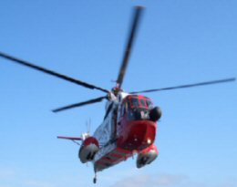
It is an actuality that breakdown, illness and injury do happen, Her Majesty Coastguard (HMCG) respond to all incidents on the coasts or at sea free of charge 24 hours a day, 7 days a week. They are also responsible for broadcasting Maritime Safety Information (MSI) using VHF, MF and NAVTEX and also the provision of a Radio Medical Link Call service (MEDILINK) in UK waters. Shetland Coastguard covers an area of 35,566 square nautical miles including both Shetland and Orkney’s coasts and waters.
Should any member of a crew require medical advice or assistance the Master or Skipper should contact Maritime Rescue Sub Centre (MRSC) Shetland using VHF or MF DSC, VHF channel 16 (156.8 MHz) or MF 2182 kHz. In an emergency situation, an urgency alert using the pro word PAN PAN should be made. The vessel will then be linked using the most suitable VHF channel or MF frequency to a doctor by the MRSC, and SAR units would be brought to immediate readiness.
Shetland has two Severn class R.N.L.I. all weather lifeboats: the Charles Lidbury based at Aith on the west and the Michael & Jane Vernon at Lerwick on the east of Shetland. As well as a rescue helicopter based at Sumburgh, on the South of the mainland, there are 33 teams of trained Volunteer Coastguards strategically placed throughout the islands. All RCCs have access to a translation service and are fitted with the latest communication equipment.
Requests for weather forecasts, general information or passing passage planning information can be made directly to MRSC Shetland 24 hours a day either by telephone on 01595 692976, VHF/MF radio telegraphy or Digital Selective Calling (DSC) using MRSC Shetlands MMSI, 002320001. Gale warnings, strong wind warnings, local navigation warnings, local inshore forecasts, extended weather outlook, navigation warnings and Sullom Voe traffic broadcasts are made at 0105 UTC and every 4 hours subsequently.
Shetland Coastguard
Knab Road
Lerwick
Shetland
Tel - 01595 692976

Doctors
Location | E-mail | Telephone
Bixter | health.centre@bixter.shetland.scot.nhs.uk | 01595 810202
Brae | brae.medicalcentre@brae.shetland.scot.nhs.uk | 01806 522543
Hillswick | health.centre@hillswick.shetland.scot.nhs.uk | 01806 503277
Lerwick | lerwick.doctors@lerwick.shetland.scot.nhs.uk | 01595 693201
Levenwick | surgery@levenwick.shetland.scot.nhs.uk | 01950 422240
Scalloway | doctors@scalloway.shetland.scot.nhs.uk | 01595 880219
Unst | health.centre@unst.shetland.scot.nhs.uk | 01957 711318
Walls | walls.surgery@walls.shetland.scot.nhs.uk | 01595 809352
Whalsay | health.centre@whalsay.shetland.scot.nhs.uk | 01806 566219
Yell | surgery@yell.shetland.scot.nhs.uk | 01957 702127

Dentists
Location | Telephone
Bells Brae Dental Clinic,  Gilbertson Road,  Lerwick,  ZE1 0QJ | 01595 693204
Yell Dental Clinic,  North Isles Dental Service,  Mid Yell,  Yell,  ZE2 9BN | 01957 702 031
Unst Dental Clinic,  North Isles Dental Service,  Haroldswick,  Unst | 01957 711255
Alan Owen,  Dental Surgery,  90 St Olaf Street,  Lerwick,  ZE1 0ES | 01595 695769

Police, Northern Constabulary
Location | Telephone
Lerwick | 01595 692110
Baltasound | 01957 711424
Brae | 01806 522381
Dunrossness | 01950 460707
Scalloway | 01595 880222
Symbister | 01806 566432
Yell | 01957 702012

Royal National Lifeboat Institution (RNLI)
Location | Telephone
Aith Lifeboat | 01595 810276
Lerwick Lifeboat | 01595 693827

