Time signals
The United States System
The transmission of signals begins at 55 minutes, 0 seconds of a given hour and continues for 5 minutes. Signals are transmitted on every second during that time, except that there is no signal on the 29th second of any minute, nor on certain seconds at the ends of the minutes, as shown in the diagram.
The dashes in the diagram indicate seconds on which signals are transmitted. The seconds marked “60” are the zero seconds of the following minutes. The dash on the beginning of the hour (shown as 59 minutes, 60 seconds) is much longer than the others.
In all cases, the beginning of the dash indicates the beginning of the second; the end of the dash is without significance.
Note that the number of dashes sounded in the group at the end of any minute indicates the number of minutes of the signal yet to be sent.
200C. The Old International (ONOGO) System
The time signal is usually preceded by a preparatory signal, described where necessary in the station listings. The signal itself is described in the following table. In the transmission of the ONOGO signals, each dash (–) =1 second and each dot (•) = 0.25 second.
200D. The New International (Modified ONOGO) System
This is identical to the old system except that six dots are sent at the 55th through 60th seconds of each minute (instead of the old system of three 1 second dashes that commenced at the 55th, 57th, and 59th seconds), which constitute the time signals.
200F. The BBC System
The time signal on the hour is preceded by five 0.1 second dots sent at seconds 55 through 59. The hour marker is a 0.5 second dash. The beginning of each dot or dash is the time reference point.

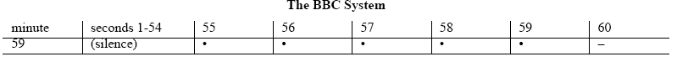

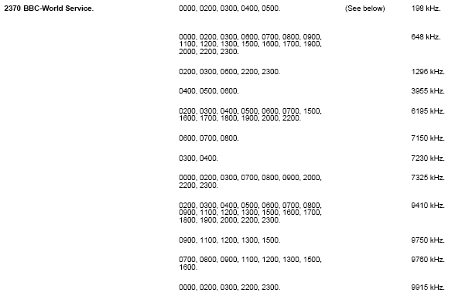

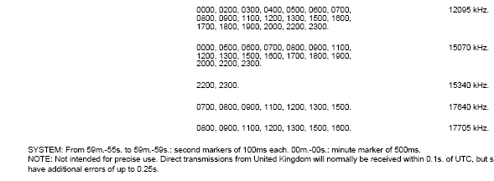

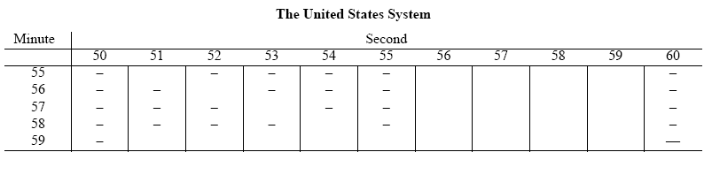

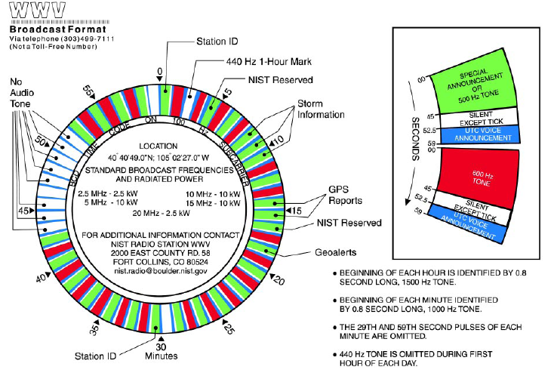

Rio | 8721 kHz (A1A)
 | 0025-0030
 | 1125-1130
 | 1325-1330
 | 1925-1930
 | 2325-2330

